Mandelbrot Benchmark Results:

Resolution | Time | Checksum | Image File

-----------+---------+----------+-----------------------

128x128 | 0.079 s | 429384 | mandelbrot_128×128.png

160x160 | 0.122 s | 669829 | mandelbrot_160×160.png

192x192 | 0.171 s | 966024 | mandelbrot_192×192.png

224x224 | 0.232 s | 1314999 | mandelbrot_224×224.png

256x256 | 0.302 s | 1715812 | mandelbrot_256×256.png

Fixed Point Arithmetic on STM32

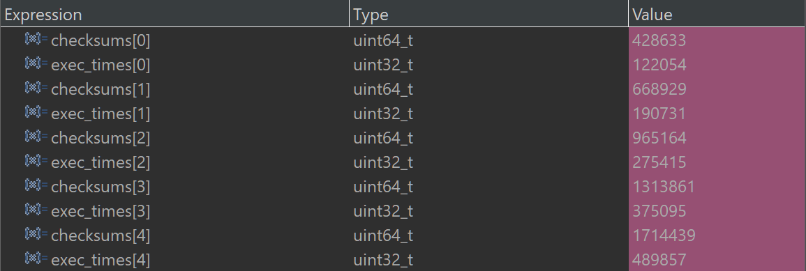

Figure : With 64-bit

Floating Point Arithmetic on STM32

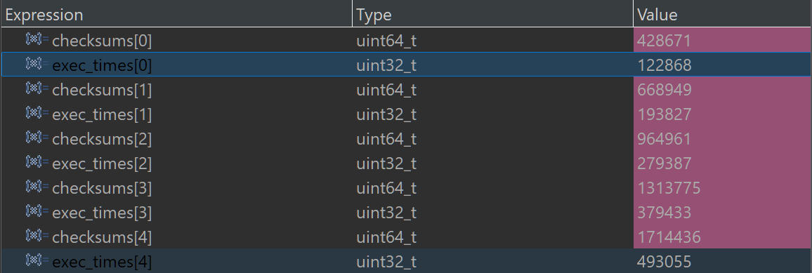

Figure : 64-bit numbers

AI CLAUSE

AI for error detection and resolution

AI for optimisation

AI for explanations